Activity Book

Innovation & Design Thinking Using Atal Idea Lab / Tinkering Lab / Makerspace

(Activity-Based Learning)

Institute Name – CMR Institute of Technology

Academic Year: 2025-26 Semester: 1

Student Name: Sachin Manjunath Roll No :F-27

Branch: AI-ML

Mentor Name: Novy Jacob
Table of Contents

Week | Module Title | Activity Title | Page No. | Sign
1–3 | Orientation and Team Formation | Communication & Team Activities | 4-5
4–5 | Empathy and Field Exploration | Stakeholder Interviews/Interaction | 6-10
6–8 | Problem Definition | “How Might We…”  Framing | 11-12
9–11 | Ideation Sprint | Brainstorming & Idea Selection | 13-14
12–14 | Prototyping | Prototype Development
15–16 | Final Demo & Social Pitch | Innovation Pitch

Sl.  No. | CIE  Component/Week | Max Marks | Description | CIE Marks Obtained | Sign
1 | Orientation Activities & Communication Skills | 5 | Participation in Week 1–3 orientation, communication and teamwork skill-building exercises.
2 | Empathy & Field Exploration Documentation | 10 | Quality and completeness of field visit reflections, stakeholder interviews, and activity book.
3 | Problem Definition and Framing | 10 | Clarity of challenge statements, use of “How Might We”, Affinity Mapping, Problem Trees.
4 | Ideation & Mind Mapping | 10 | Participation in brainstorming, mind mapping, idea filtering sessions.
5 | Prototype Development & Iteration | 10 | Quality and creativity of prototype/model, user testing, feedback collection, iterations.
6 | Teamwork, Journal, and Engagement | 5 | Peer and mentor evaluation of participation, teamwork, journal updates.
7 | Total CIE marks | 50 | Final CIE marks to be considered

Week 1–3: Orientation & Team Formation
- Activity Title: Camouflage Technology: Research and develop innovative camouflage technology that can help soldiers blend into their surroundings more effectively.
- Objective: To research and develop a basic prototype of camouflage technology inspired by chameleons and octopuses.
To explore how sensors and programmed color-changing LEDs can help an object blend into its surroundings.
To understand how camouflage can support soldiers by reducing visibility and increasing safety.
To study limitations, real-world applications, and future improvements for adaptive camouflage in defence and fashion industries.

- Tasks Done: Researched natural camouflage found in chameleons, octopuses, and military stealth systems.

Identified suitable sensors (LDR/Color Sensor/IR sensor) and selected electronic components such as Arduino and LEDs.

Designed the working concept: detect background → read sensor value → change LED color accordingly.

Created circuit connections and basic Arduino code for reading sensor input and triggering LED output.

Built a small prototype to demonstrate color adaptation.

Analyzed challenges such as accuracy, limited color range, sensor delays, and need for flexible LED screens.

Prepared diagrams, flowcharts, and design sketches for the project.

- Skills Developed:
Technical Skills-
Basics of Arduino programming
Understanding sensors (LDR, color sensor, IR) and electronic connections
Circuit building and troubleshooting
Reading and interpreting data (sensor values, outputs)

Conceptual Skills-
Understanding natural camouflage systems
Translating biological inspiration into engineering solutions
Problem-solving and modifying design based on limitations

Soft Skills-
Teamwork
Time management during prototype development
Presentation and documentation skills

- Output / Reflections: Successfully created a working mini-prototype where lights change based on the detected environment.

Learned how real camouflage technology requires fast sensors, accurate color detection, and flexible display materials.

Understood that this technology can help soldiers reduce visibility on the battlefield, protect assets, and increase survival — but also has limitations like weather conditions, cost, and durability.

Overall, the project improved creativity, technical thinking, and understanding of how nature inspires engineering solutions.

- Faculty Signature with remarks

Week 4–5: Empathy & Field Exploration
- Field Visit Location: Auto EV Bharath 2025
- Date of Visit:22-11-25
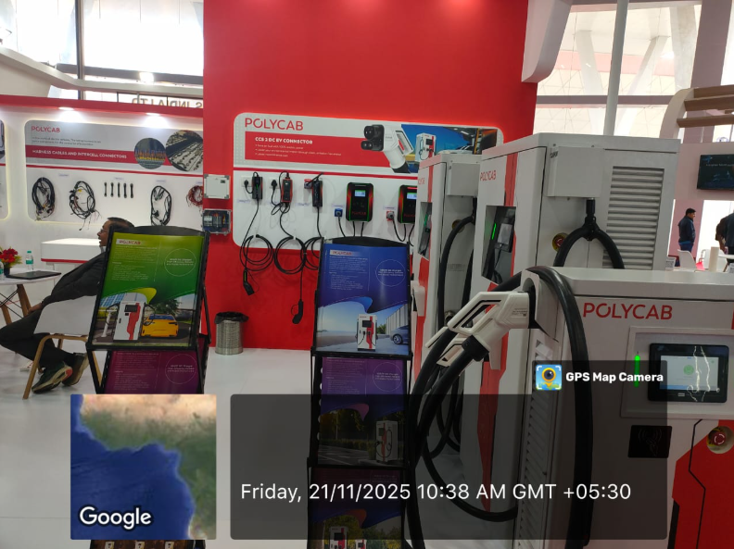

During our visit to the Auto EV Bharath Expo , we interact with different stakeholders involved in the electric vehicle ecosystem. We spoke with EV manufacturers, battery suppliers, charging - station developers, and customers who use EVs daily.
Through these interactions, we understood their expectations, challenges and motivations. Manufacturers highlighted the need of cost-effective components. while suppliers focused on improved battery safety and lifespar. Charging station providers discussed issues eike laid availability and power load requirements. customers expressed concerns about charging time, rage anxiety dud service support.
Overall, the field visit helped us develop empathy by seeing real-world problems from multiple viewpoints, which will guide us in designing better solutions for EV users.
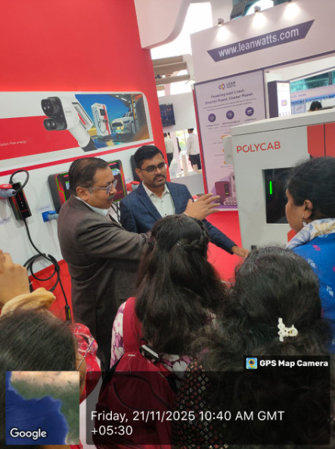
POLYCAB INDIA
As part of our empathy and field exploration activity, we visited the Auto EV Bharat Expo, a major exhibition showcasing the latest innovations in the electric vehicle sector. The objective of the visit was to interact with stakeholders, understand their needs, observe real-world challenges, and develop user-centred insights.

- Stakeholders Met:
During the expo, we engaged with several key stakeholders:
- EV Manufacturers — Two wheeler and Three wheeler companies
- Battery manufacturers — Lithium-ion, solid state, and wearable pack suppliers
- Charging infrastructure companies
- Dealers and Distributors
- End users( EV owners and potential buyers)
- Policy representatives
-We gained first first-hand insights instead of theoretical knowledge
-Saw how different stakeholders depend on each other
- Understood gaps between user expectations and industry offerings.
- Realized the importance of designing EV solutions that are safe, affordable, and user-friendly.

- Key insights gained are and questions asked:

-Demand for EVs is growing, but affordability remains a barrier. Many companies are working on lighter chassis and improved aerodynamics. Manufacturers stressed the importance of design differentiation, safety, and durability.

- Battery overheating and lifespan are major concerns. Companies are investing in LFP and solid-state technology. They emphasized safe charging cycles and efficient thermal management systems.

-The biggest challenge is infrastructure availability. High installation cost.

- They are working on fast charging and portable charging solutions.

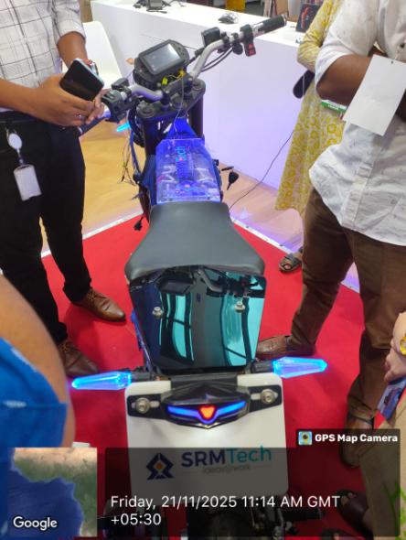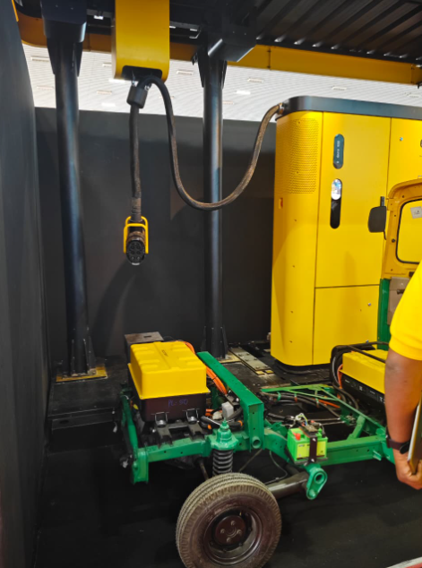

- From customers / users:
Main concerns are:
* range anxiety
* charging time
* battery replacement cost
* lack of service centers

Users said they prefer EVs for cost efficiency and lower maintenance

- Empathy Mapping:
User felt: curious, concerned about safety, hopeful about new technology.
User thinks: Is it reliable? Will the battery last long?
EVs are seen as economical but charging options are still limited.
Users compare brands, ask about battery warranty, check range and speed.
-We gained first-hand insights instead of theoretical knowledge. Saw how different stakeholders depend on each other. Understood the gaps between user expectations and industry offerings. Realized the importance of designing EV solutions that are safe, affordable and user friendly.

- Conclusion
The Auto EV Bharat Expo served as an excellent opportunity for empathy and field exploration. By interacting directly with diverse stakeholders, we understood real needs and challenges in the EV ecosystem. These insights will help us approach problem solving with a more user-centred mindset.

The hands-on exploration strengthened our empathy by allowing us to see industry from multiple perspectives — technical, commercial, and user-centric. Overall, the field experience helped bridge the gap between theoretical learning and real-world application, motivating us to think more critically and innovatively about sustainable mobility solutions in the future.
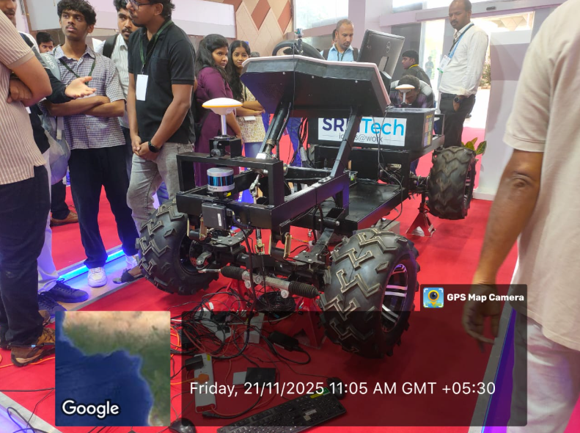

- Challenges Noted:
1. Charging Infrastructure

* The lack of a robust charging network remains a big hurdle; despite EV vehicle launches, charger coverage is limited.
* Interoperability and standardization: there is a need for systems that work across different EVs and charger brands.

2. Range Anxiety / User Confidence

* Consumers are worried about how far an EV can go before needing a charge — “range anxiety” is still a major barrier.
* Despite improvements in battery tech, this anxiety persists and is compounded by limited charging infrastructure.

3. Skill Gap

* The Automotive Skill Development Council (ASDC) pointed out shortages in skilled manpower for EV battery manufacturing, recycling, and safety.

- Faculty Feedback & Signature:

Week 6–8: Problem Definition
- List of Problems Identified:
- Soldiers are easily detected in modern battlefields due to advanced surveillance systems.
- Traditional camouflage uniforms work only in limited environments (forest/desert/snow).
- Current camouflage does not adapt to changing surroundings in real time.
- Thermal cameras can detect body heat even if visual camouflage is effective.
- Soldiers’ safety is compromised due to poor concealment.
- Environmental conditions like lighting and weather reduce camouflage effectiveness.
- Heavy and uncomfortable camouflage gear reduces mobility.
- High cost of advanced camouflage materials limits mass usage.
- Lack of smart technology integration in existing military uniforms.
- Difficulty in remaining hidden during day-night transitions.

- Empathy Map / Problem Tree Analysis or Drawing:
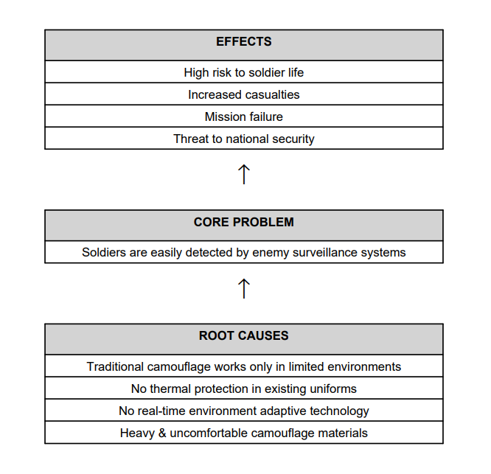

- Defined Problem Statement:
To design and develop an innovative and adaptive camouflage technology that helps soldiers blend into different environments in real time while reducing detection by visual and thermal surveillance systems.

- User Pain Points Identified w.r.t. Defined Problem Statement:
- Soldiers feel unsafe due to high chances of detection.
- Traditional uniforms do not change with surroundings.
- Detection through thermal sensors is unavoidable with current gear.
- Heavy camouflage equipment causes discomfort and fatigue.
- Soldiers cannot operate freely due to visibility risks.
- No real-time environment sensing in present uniforms.
- Reduced confidence during night and drone-based surveillance.
- High dependence on hiding behind physical objects.

- Faculty Feedback & Signature:

Week 9–11: Ideation Sprint

- Techniques/Platforms Used: Brainstorming Sessions/ Group Discussions/Mentoring/Mind Mapping
- Ideas Generated (List 10 or more):
- Color-Changing Camouflage Uniform – Fabric that changes color based on surroundings.
- Thermal Invisibility Jacket – Reduces heat signature from enemy thermal cameras.
- Smart Adaptive Helmet – Helmet that changes shade automatically using sensors.
- Camouflage Face Paint with Heat Control – Paint that hides both visibility and thermal signs.
- Drone-Activated Camouflage Shield – Portable shield activated by drone surveillance.
- AI-Based Environment Recognition Suit – Uses AI to detect terrain and adjust texture.
- Sound-Absorbing Camouflage Gear – Reduces sound while moving in combat zones.
- Smart Camouflage Tent for Soldiers – Tent that blends into forest, desert, or snow.
- Water-Proof Chameleon Fabric Uniform – Works effectively in rainy or wet conditions.
- Urban Digital Camouflage Suit – Special design for city warfare.
- Solar-Powered Adaptive Camouflage Suit – Uses renewable energy to change appearance.

- Idea Selected for Prototyping: Camouflage Technology: Research and develop innovative camouflage technology that can help soldiers blend into their surroundings more effectively.

- Justification for Selection:

- Provides real-time color and texture adaptation based on the environment.
- Increases soldier safety and survival rate.
- Can be used in multiple terrains – forest, desert, snow, urban areas.
- Uses modern technologies like sensors, microcontrollers, and smart fabric.
- Has high real-world military application potential.
- Easy to scale and upgrade with future technologies.

- Initial Design Sketch:

_________
| Transparent Cover Layer | ← protects electronics

| LED Display Sheet | ← shows camouflage colors

| Sensor Module (LDR or |
| Color Sensor placed here| ← detects light/color

| Arduino + Wiring | ← brain of system

| Battery/Power Source |

- Faculty Feedback & Signature:

Week 12–14: Prototyping
- Materials Used:
Arduino UNO r3/ IDR Sensor module/LDR Sensor (Light Dependent Resistor)/ Color Sensor (like TCS3200 / TCS34725) / LEDs (Output Indicator )/ OLED Display (0.96" I2C)
- Prototype Description: The prototype developed in this project demonstrates a basic adaptive camouflage system inspired by creatures like chameleons and octopuses, which naturally blend into their surroundings. The aim of the prototype is to show how technology can help a surface detect nearby colors and adjust its appearance to match the background.

1. Prototype Components
The system mainly includes:

- Color Sensor Module – Detects the color of the surrounding surface.
- Microcontroller (Arduino UNO) – Processes the sensor readings.
- LEDs / LED Panel – Changes color according to the detected environment.
- IR Sensor (optional) – Detects obstacles or proximity if needed.
- Power Supply & Basic Circuit Components

2. Working Principle
- 1. The color sensor scans the surface placed in front of it.
- 2. The data is sent to the Arduino, which interprets the RGB values.
- 3. The microcontroller then adjusts the LEDs to produce the same or closest possible color.
- 4. This creates the effect of color blending, which mimics natural camouflage behavior.

3. Purpose of the Prototype

- To show how automated camouflage systems can function using simple sensors and programmable logic.
- To demonstrate how real-time color detection can be used to improve soldier safety, stealth technology, and environment-responsive devices.
- To represent an initial model that can be scaled into more advanced, flexible camouflage surfaces in the future.

4. Key Features
- Real-time color detection
- Automatic color adaptation
- Simple and low-cost design
- Expandable (more LEDs, flexible display, advanced sensors)

5. Limitations
- Limited color accuracy compared to advanced military systems
- Works only on small surfaces
- LEDs cannot fully mimic texture or complex patterns

- 6. Future Enhancements
- Using flexible OLED displays for better blending
- Adding pattern recognition for environment textures
- Improving response time and color accuracy
- Integrating AI-based adaptive camouflage

- Photos of Model (attach separately):

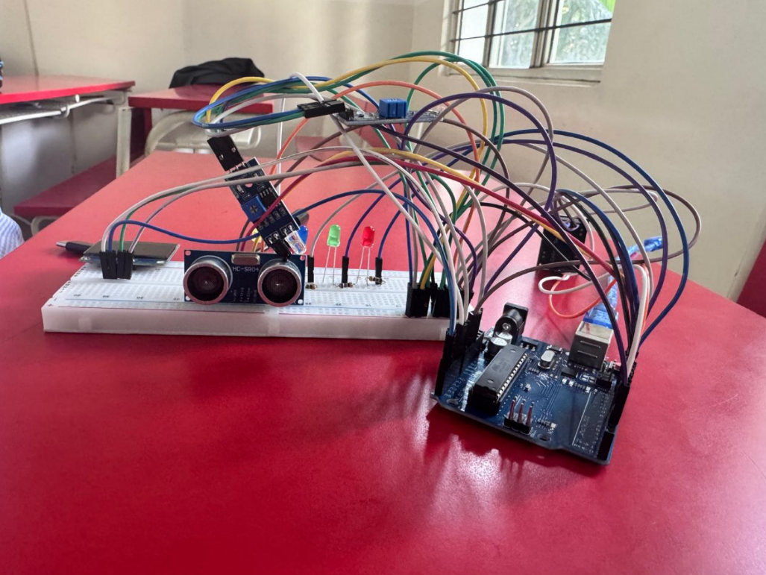
- User Testing Report:
User testing was conducted by demonstrating the camouflage technology model/simulation to a small group of users including classmates and a faculty guide. The users observed the working of the system under different background conditions and lighting environments. The performance of the camouflage system was evaluated based on visibility reduction, response time, and overall effectiveness in blending with surroundings. The system functioned as expected and successfully demonstrated the basic concept of camouflage technology.

- Feedback Received :
- Camouflage effect works better in controlled lighting conditions
- Color matching accuracy can be improved for complex backgrounds
- Transition between different backgrounds could be smoother
- System concept is clear and easy to understand
- Practical applications were well explained, but real-world limitations should be highlighted more
- Overall presentation and demonstration were satisfactory
- Revisions Made:
- • Improved color adjustment logic to enhance background matching
- • Reduced response time for switching between camouflage patterns
- • Added explanation of limitations and real-world challenges
- • Enhanced visual clarity of the model for better demonstration
- • Improved documentation and flow of explanation based on feedback

- Faculty Feedback & Signature:

Week 15–16: Final Demo & Pitch
- Project/Idea Title: “Smart Camouflage technology”
- Team Members:
Sachin Manjunath(F-27),
S Preetham(F-26), and
SM Venkatesh Babu(F-25)

- Targeted Problem:
In many defense and security applications, personnel and equipment are easily detected due to their inability to adapt to changing environmental backgrounds. Traditional camouflage methods are static and effective only in specific surroundings. This project targets the problem of visibility and detectability by exploring camouflage technology that can adapt to different background conditions, thereby improving concealment and reducing the chances of detection.
- Final Report of the Project: Attached Separately
- Pitch Summary: Poster/PPT: Attached Separately

- Jury Comments:

- Marks (out of 50):

- Faculty Signature:

Final Reflection & Self-Assessment
- What did I learn from this course?
Through this course and mini project on camouflage technology, I gained a clear understanding of how theoretical concepts can be applied to solve real-world problems. I learned the basic principles behind camouflage, including color matching, pattern adaptation, and the impact of lighting and background conditions. The course also helped me understand the importance of planning, testing, and improving a system based on feedback.

- Skills I gained:
- Basic research and technical documentation skills
- Problem-solving and analytical thinking
- Practical understanding of camouflage and concealment principles
- System testing and performance evaluation
- Presentation and communication skills
- Teamwork and time management skills

- Challenges I faced and overcame:
One of the main challenges was understanding how camouflage behaves under different lighting and background conditions. Another challenge was optimizing the system response to make the transitions smoother. These challenges were overcome through repeated testing, guidance from faculty, and studying reference materials. Managing time and coordinating tasks also required effort, which improved over the course of the project.

- What would I do differently next time?
If given another opportunity, I would focus on using more advanced techniques to improve accuracy and realism. I would also conduct more extensive testing in real-world environments and include additional features such as automated background detection. Better planning at an early stage and more detailed performance analysis would further improve the project outcome.

- Faculty Suggestions:

THANK YOU!

I sincerely thank my faculty guide and institution for their guidance and support throughout the completion of this mini project. I also thank my friends and family for their encouragement.

